**ADMIN MANUAL**

**Of**

**AL NAHDI SAFARIS**

**Website**

**Table of Contents**

**1 - Login Page**

**2 - Dashboard**

**3 - Add Admin**

**4 - Web User**

**4.1 - All User**

**4.2 - Add User**

**4.3 - Action:-**

**4.4 - Add Order**

**4.5 - Order History**

**5 - Notification**

**5.1 - Order History**

**6 - Reports**

**6.1 - Status Reports**

**7 - Add Coupon**

**7.1 - Add Coupon**

**7.2 - Coupon List**

**7.3 - Assign Coupon**

**8 - Blog**

**8.1 - Add**

**8.2 - Blog list**

**9 - Boarding Point**

**9.1 - Add**

**9.2 - Boarding List**

**10 - Package Type**

**10.1 - Package**

**10.2 - Package list**

**11 - Adventure**

**11.1 - Add**

**11.2 - Adventure list**

**12 - Destination**

**12.1 - Add**

**12.2 - Destination list**

**13 - Special Tour**

**13.1 - ADD**

**13.2 - Special Tour list**

**14 - Room Sharing**

**14.1 - Add**

**14.2 - Room Sharing list**

**15 - Make a Tour**

**15.1 - Add**

**15.2 - Trip List**

**16 - Add Menu**

**16.1 - Manu List**

**17 - Other Charge**

**17.1 - Other Charge List**

**18 - Add Gallery**

**18.1 - Add Gallery**

**18.2 - Gallery List**

**19 - Add Video**

**19.1 - Add Video**

**19.2 - Video list**

**Login Page**: -

Step 1 => To get access to the Login Page, enter the correct username and password.

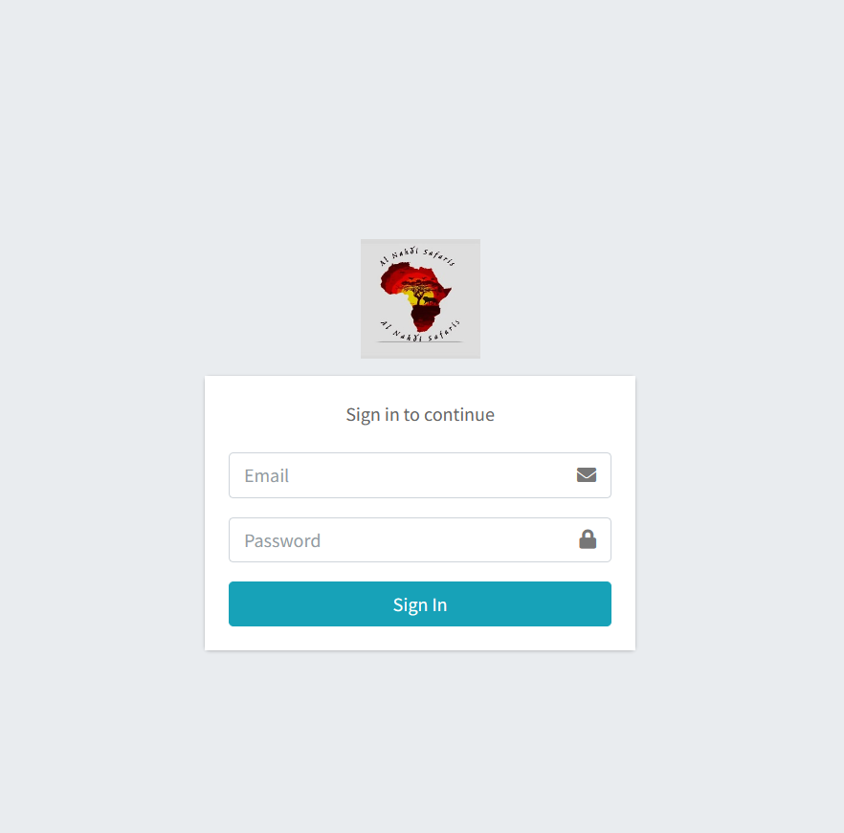

Step 2 => After Signing In, the admin is redirected to the Dashboard Page.

1 - Dashboard: -

Step 1 => This is the Dashboard Page where the admin can control all the features.

Step 2 => In the upper-right corner, we can see the notifications about the payments made or canceled. Click on the bell icon to see the notifications.

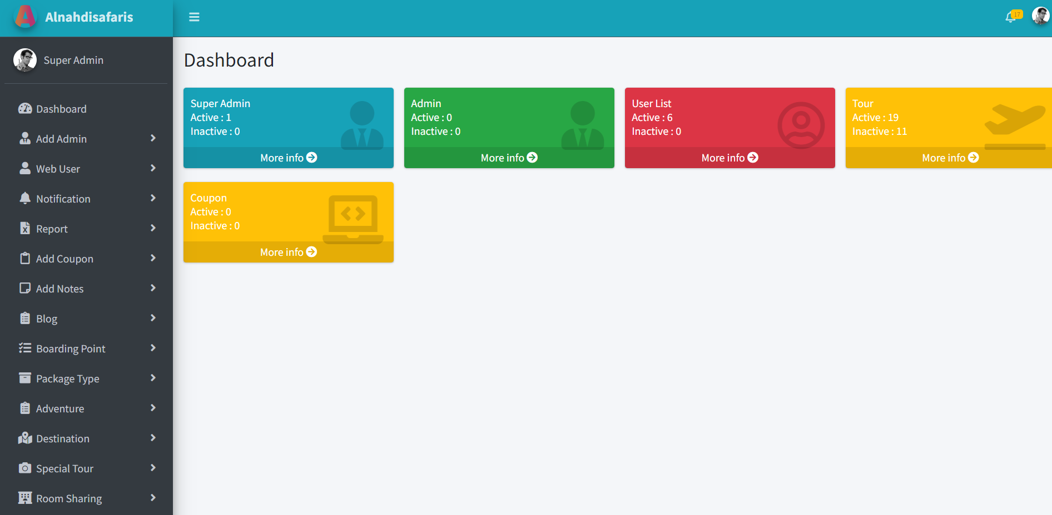

2 – Create Admin: -

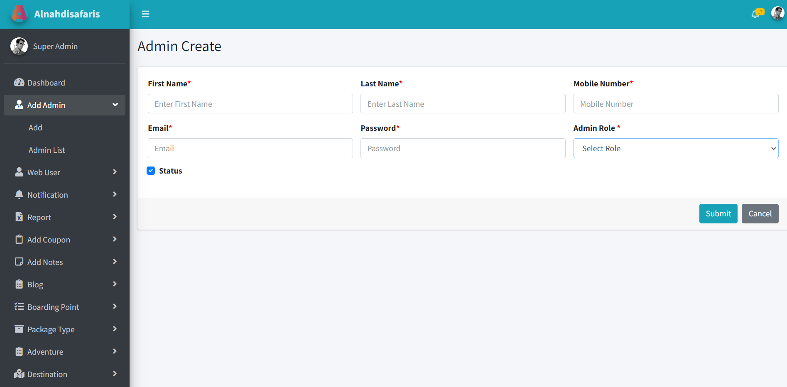Step 1 => To give access to Admin Control to a new admin, click on ‘Add Admin’ and then click on ‘Add’.

Step 2 => Enter the necessary details and mention the ‘Admin Role’.

Step 3 => There are 2 roles for Admin i.e., Admin & Super Admin.

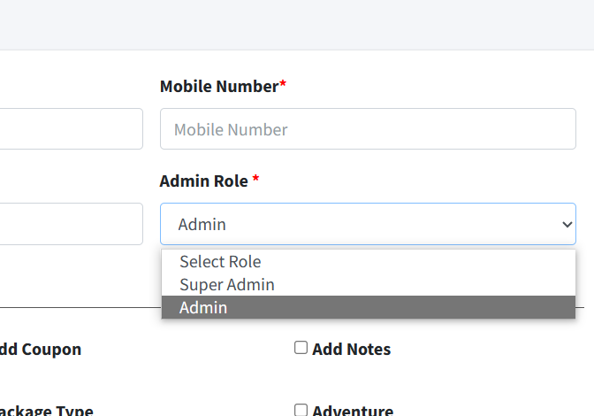

\*\***ADMIN ROLE**\*\* = Here, we can assign specific roles to the Admin and the Admin will only be able to access the specific roles data.

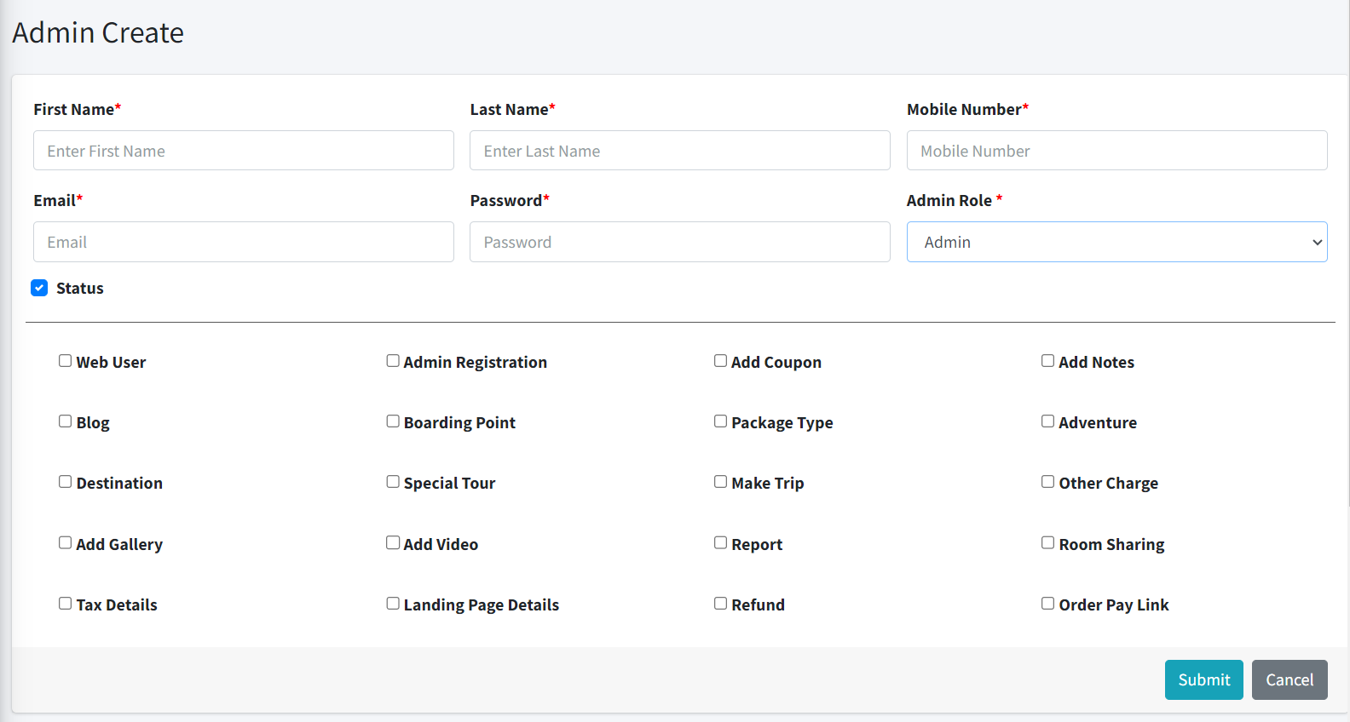

\*\***SUPER ADMIN ROLE**\*\* = Here, we assign the whole control of the Admin Panel, and the Super Admin can access the whole data.

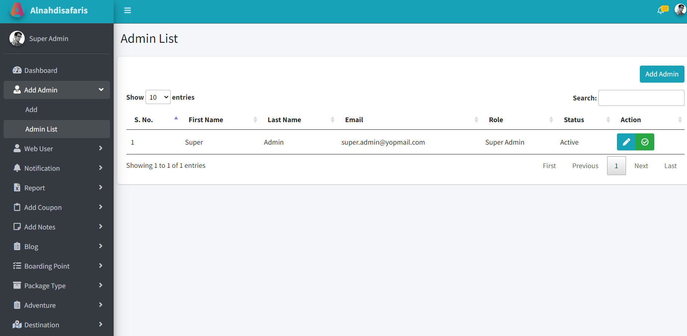2.1 – Admin List: -

=> This is the page where we can see how many admins are having access to the Admin Panel and what role they carry with them with their status, and we can change the details as well.

3 - Web User: -

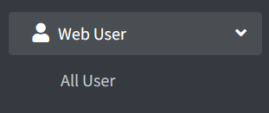

3.1 - All Users: -

=> The admins here can see how many users have booked the trip.

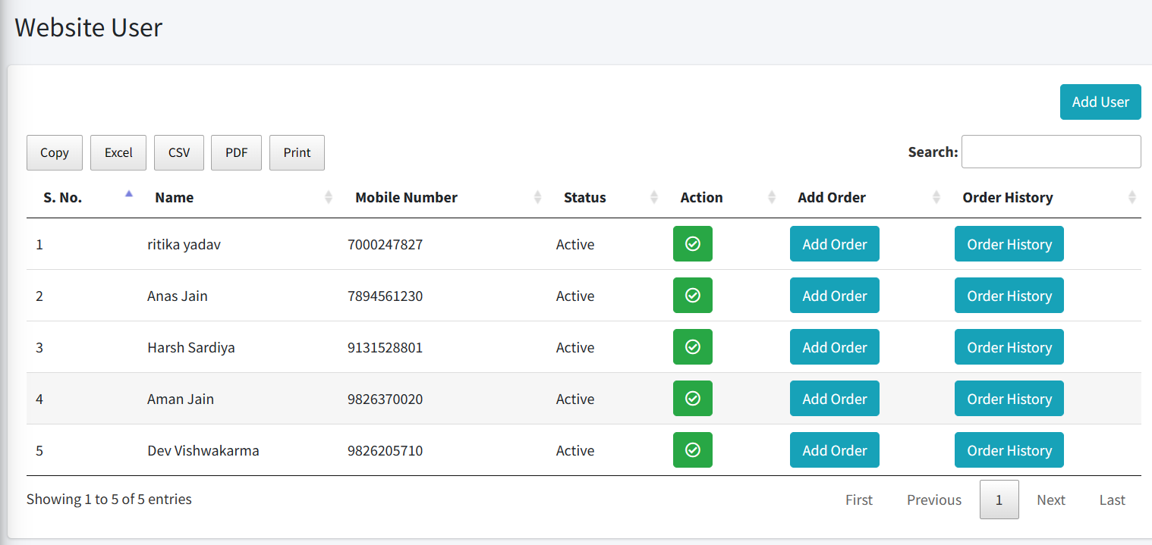

=> The admin can export this data with Excel, .csv files, and pdf and can print the data as well.

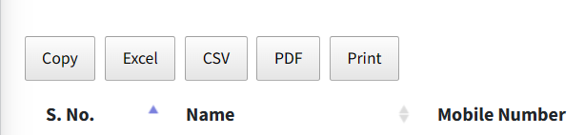

3.2 - Add User: -

=> Admins can Add Users manually according to their roles assigned.

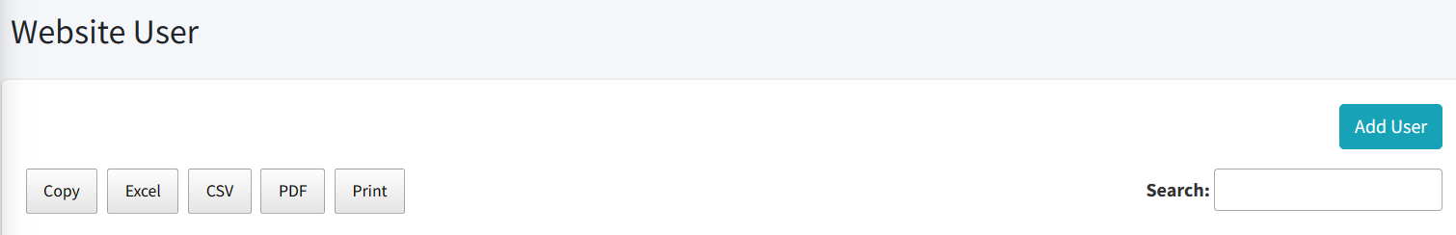

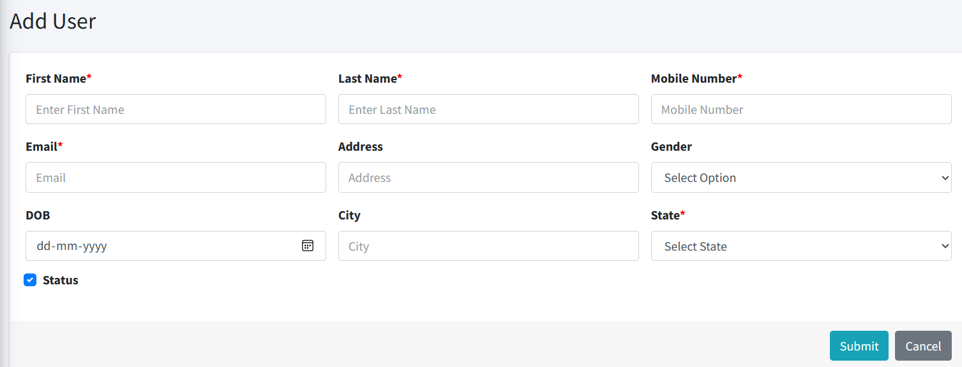

3.3 - Action: -

=> Admins can take action against active and inactive user IDs.

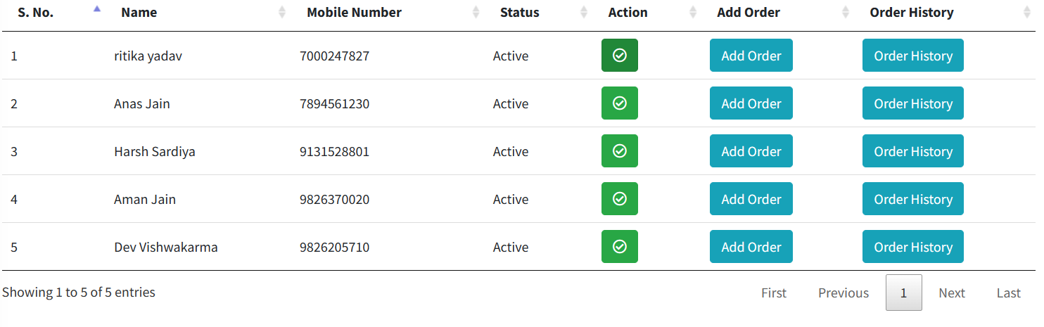

3.4 - Add Order: -

=> Admin can Also add order manually when super admin allows admin to add.

=> Admin can confirm it from their side as well.

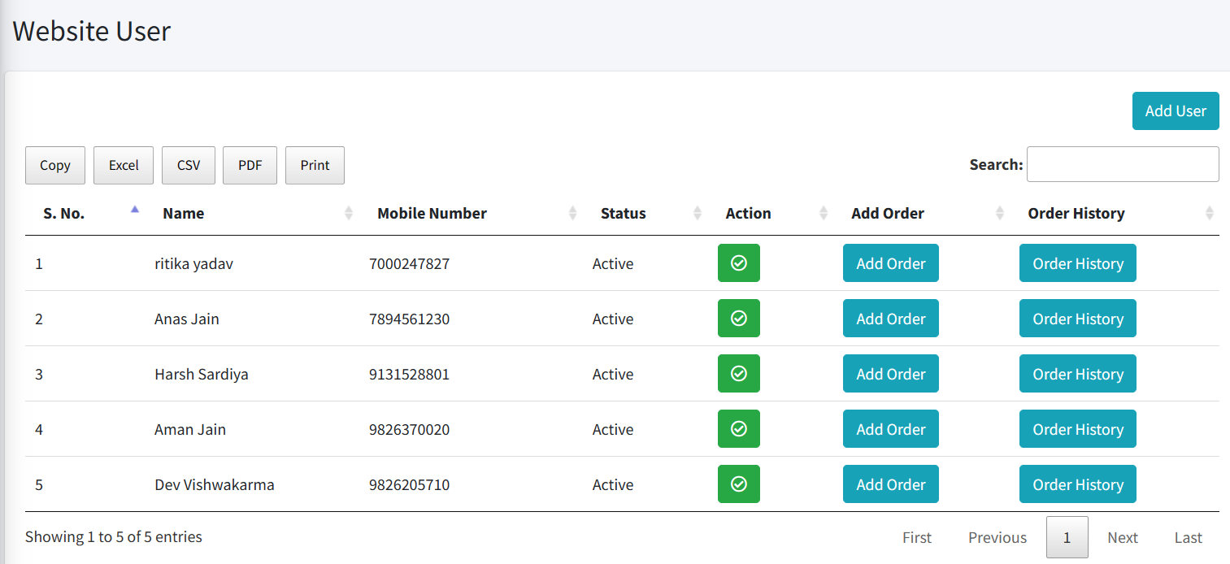

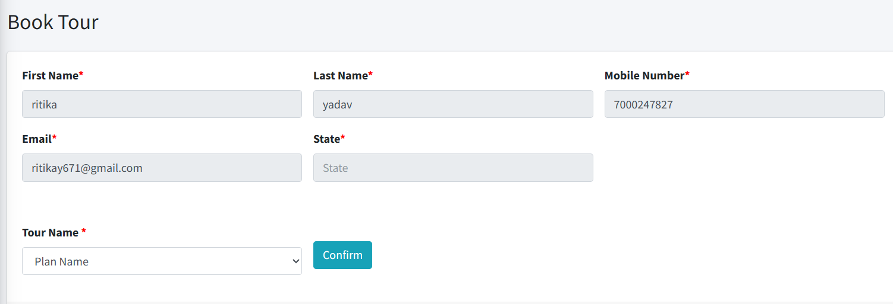

3.5 - Order History: -

=> They can also view a particular user’s profile and see how many packages they have booked in the past.



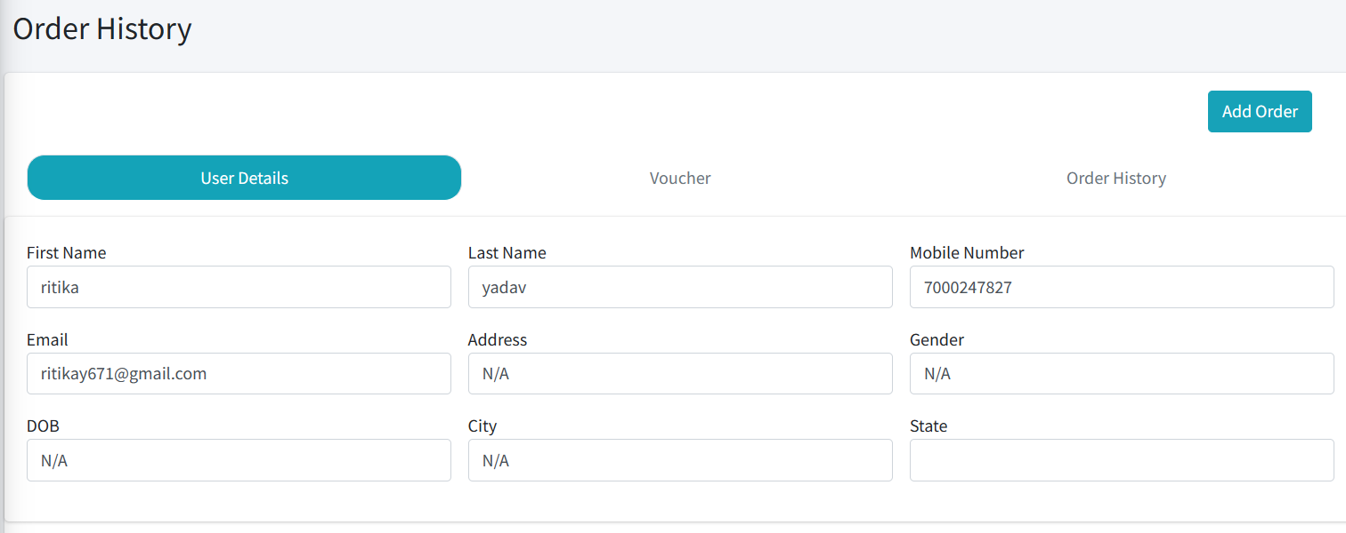

4- Notification: -

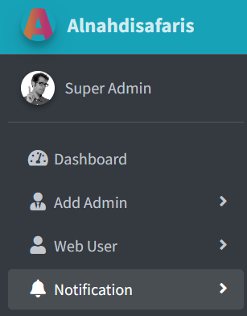

=> The admin can see from the notifications about the payments made or canceled.

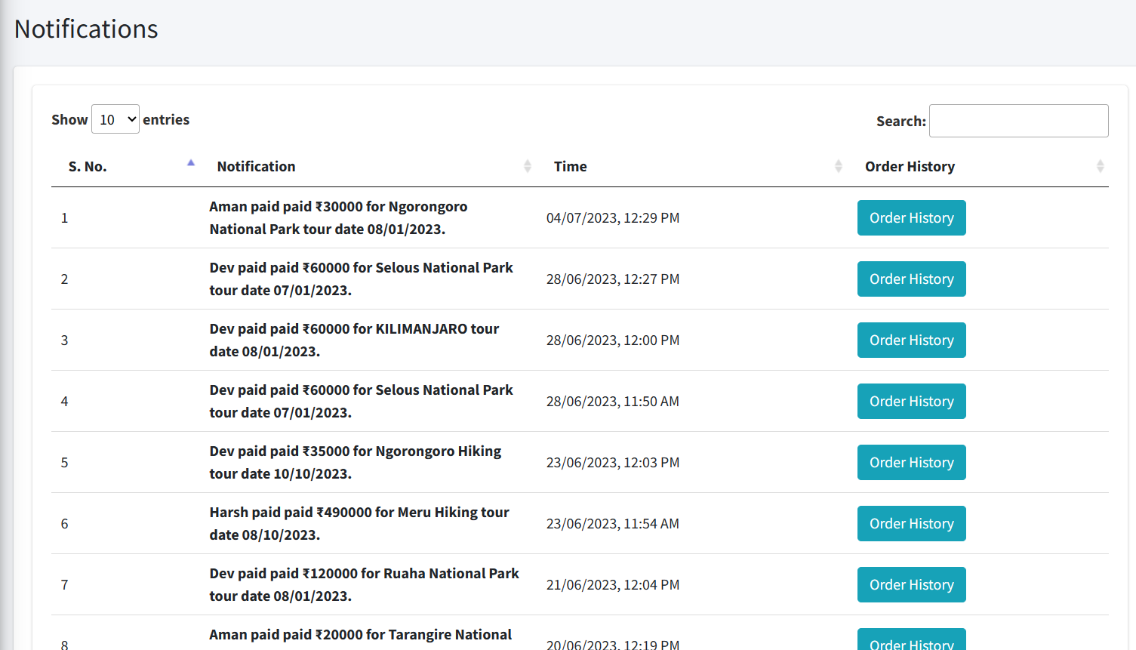

=>> The Admin can also search for the older entries as well. (notifications)

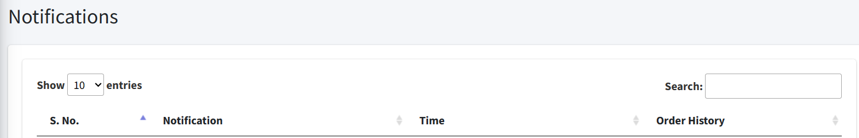

4.1 - Order History: -

=> The Admin can check the order history from the previous entries.



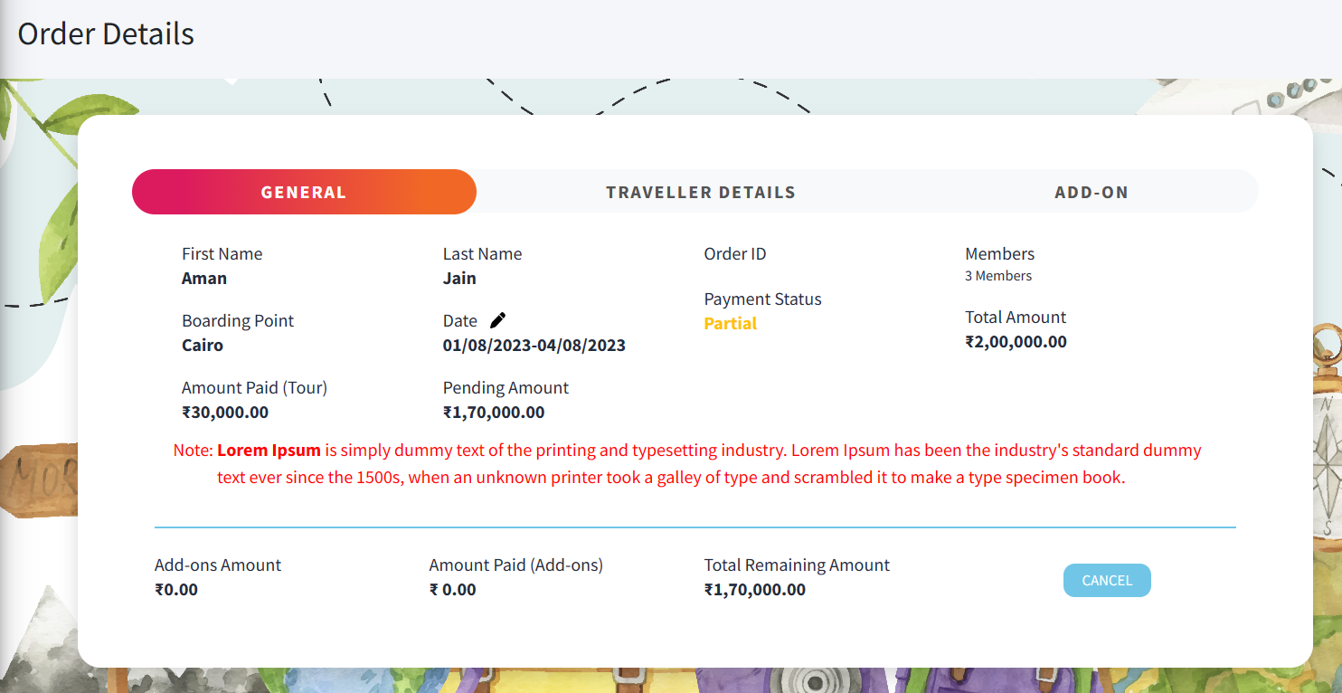

5 - Reports: -

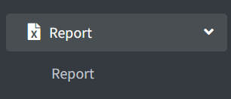

=> The Report Page where the admin can see the user details and have the option to check an individual report by giving the tour name, date, and status.

=> The Report Page where the admin can see how many users have booked a tour and what the amount of their tour is, how much amount is paid, and the remaining amount.

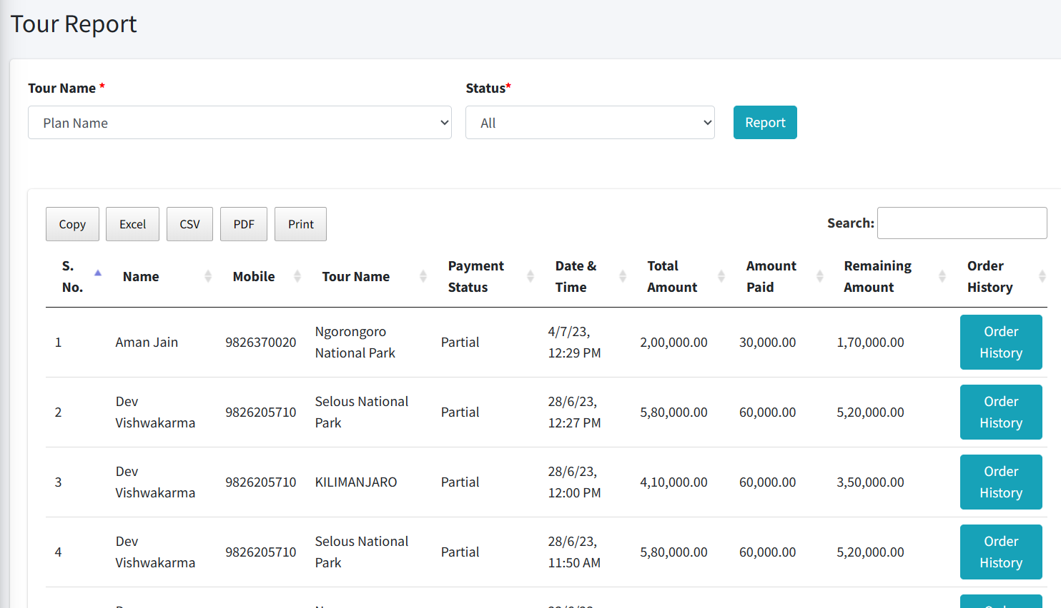

5.1 - Status Reports: -

=> There are three options to see the reports, i.e., Complete, Partial, and Cancel.

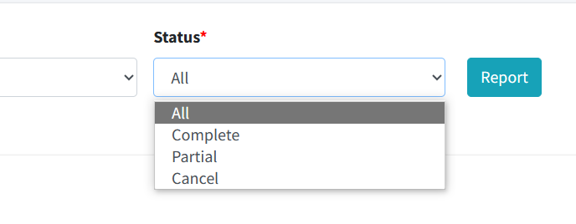

* Complete Payment

Here we can see complete payments made by the user.

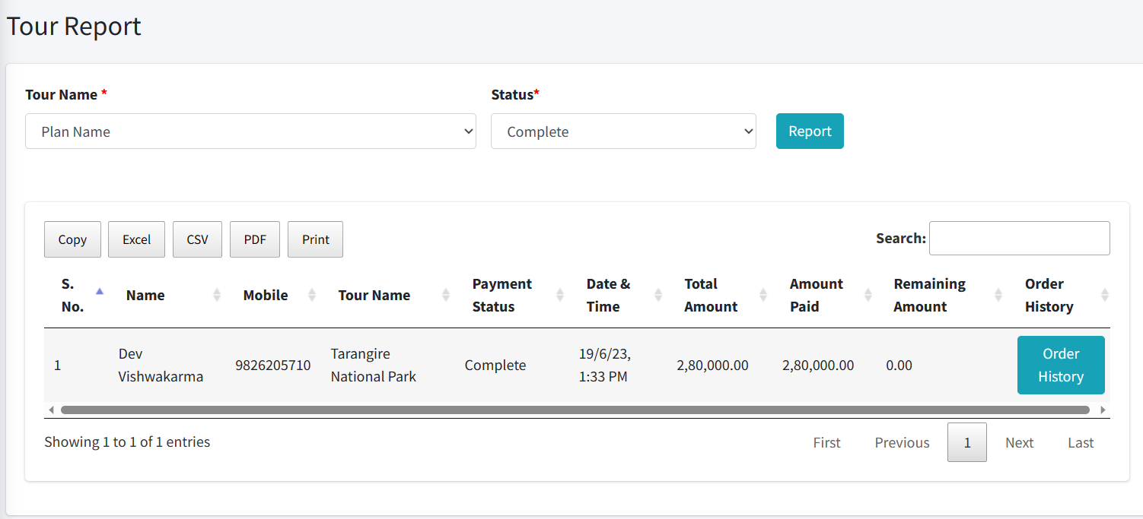

* Partial Payment

Here we can see partial payments made by the user.

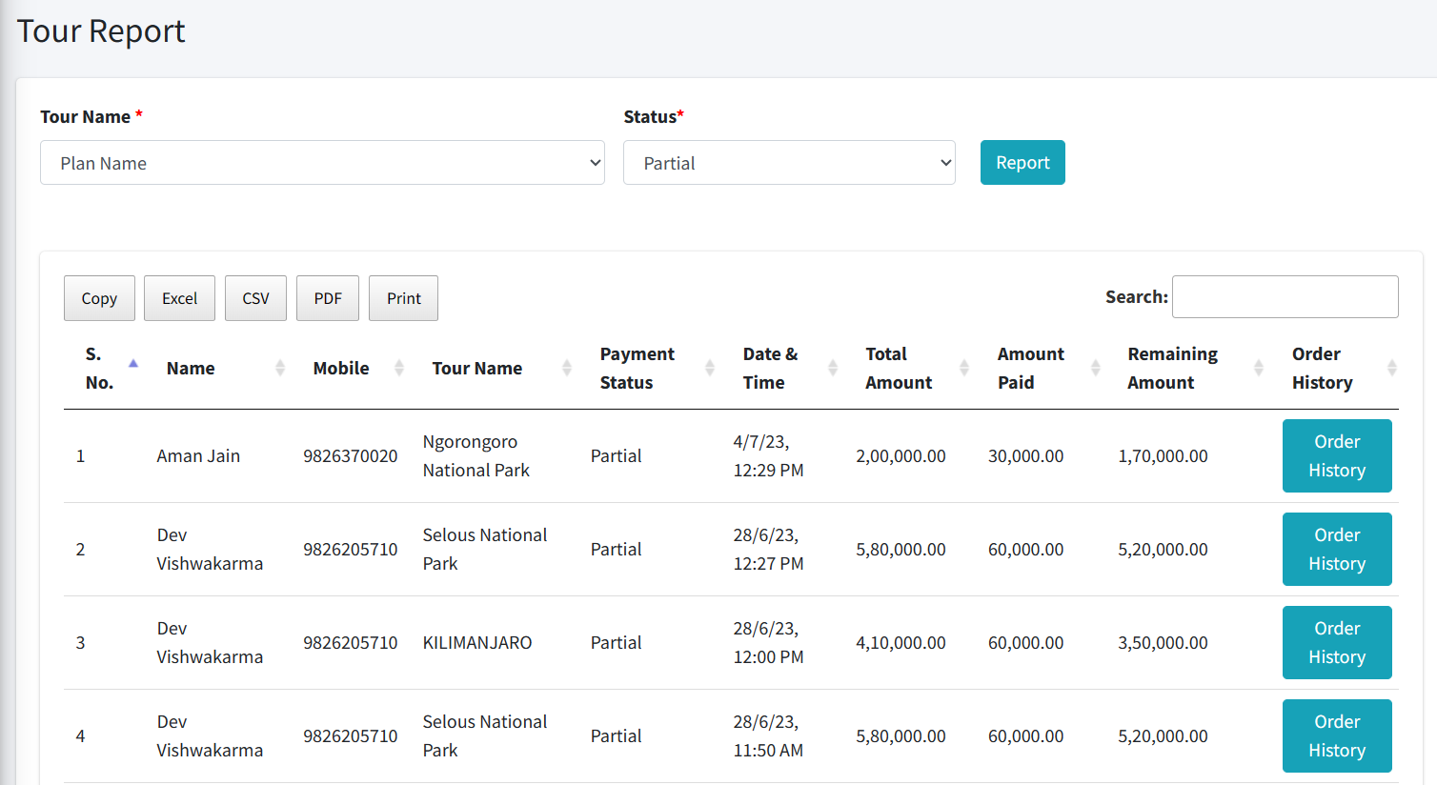

* Cancel Payment

Here we can see cancel payments.

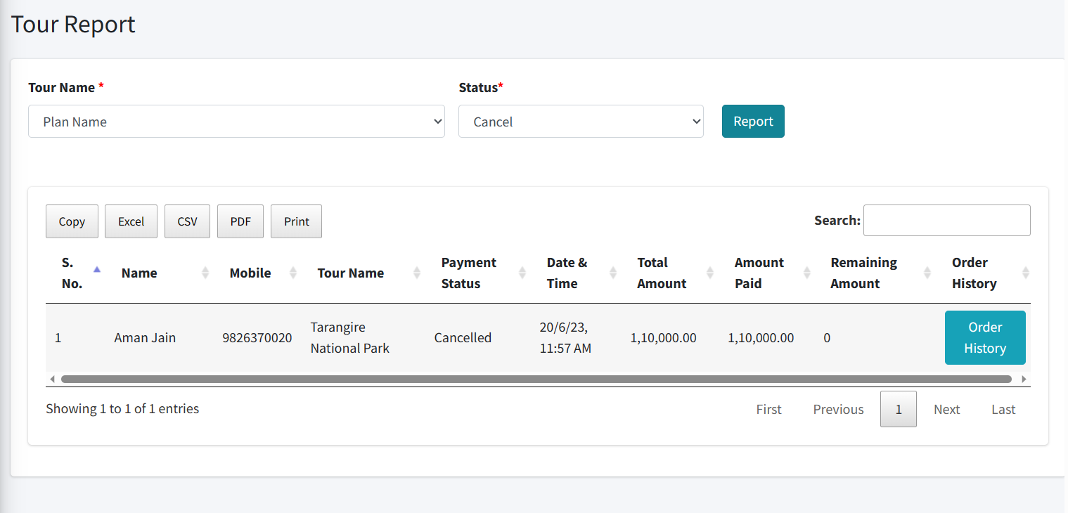

6 - Add Coupon: -

=> There are three options to create a **coupon**, **coupon list,** and **assign coupon.**

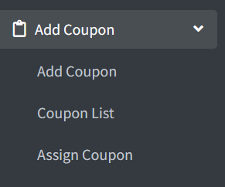

6.1 - Add Coupon: -

=> Here we can create a coupon of our own choice and then mention the code, the coupon description, and the type of discount with the amount percentage.

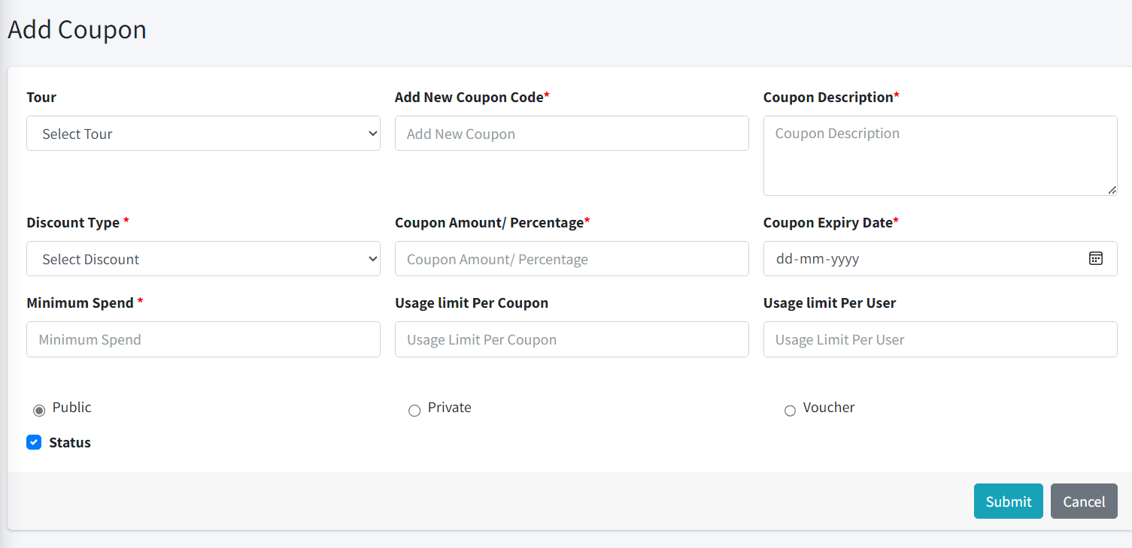

6.2 - Coupon List: -

=> Here we can see the coupon list.

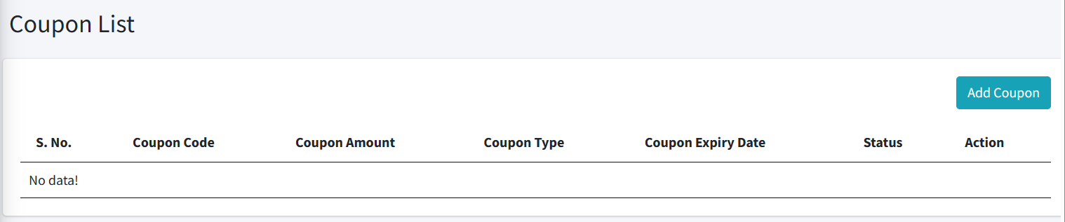

6.3 - Assign Coupon: -

=> Here we can assign coupons to users.

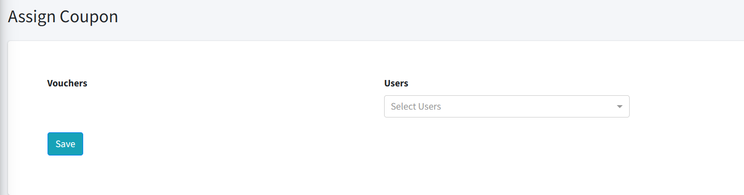

7-Add Notes: -

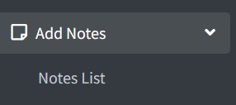

=> Here we can see the notes list.

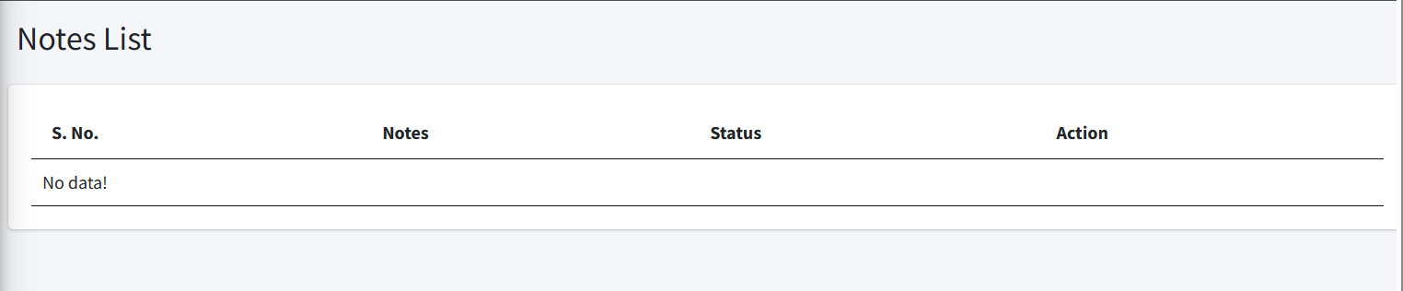

8 - Blog: -

=> Here we have two options i.e., to **create a blog** and to **view the blog list.**

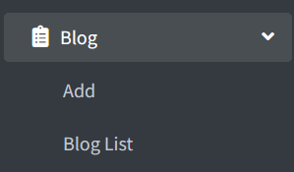

8.1 - Add: -

=> Here we can create a blog with a destination of a particular place with images and content.

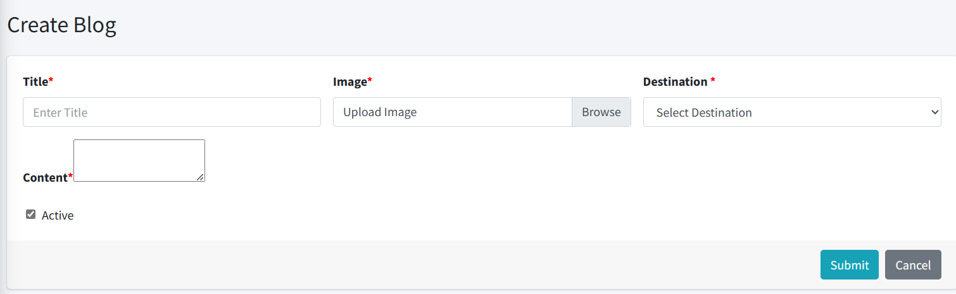

8.2 - Blog list: -

=> Here we can see the blog list.

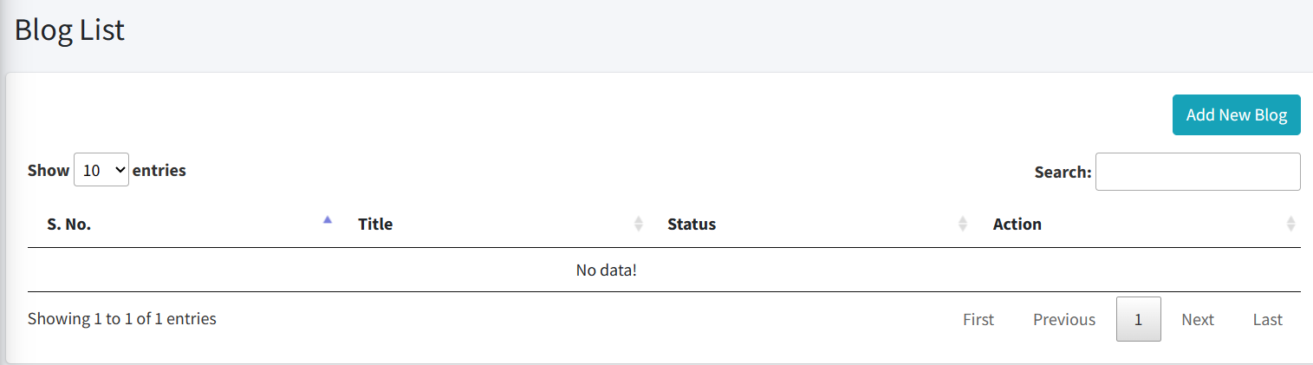

9 - Boarding Point: -

=> The admin has the option to **add a boarding point** and **view the boarding list.**

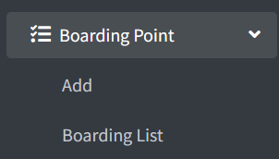

9.1 - Add: -

=> Here we can Add a Boarding point.

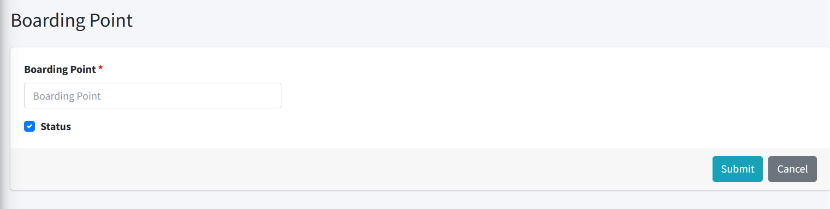

9.2 - Boarding List

=> Here we can see the Boarding list.

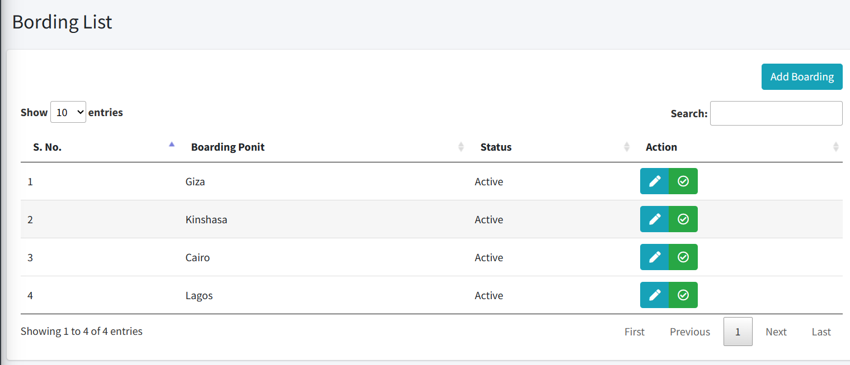

10 - Package Type: -

=> Here we have two options to **Add a package** and **view the package list.**

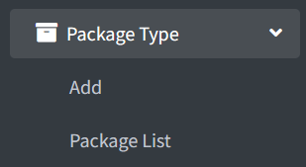

10.1 - Package

Here we can add the package.

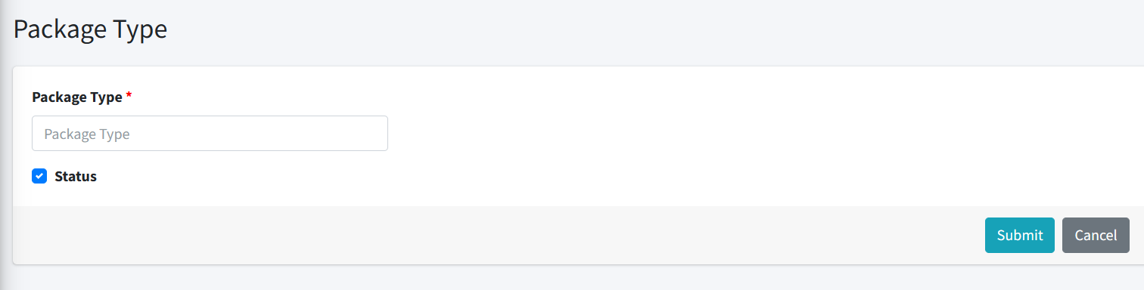

10.2 - Package list

Here we can see the package list.

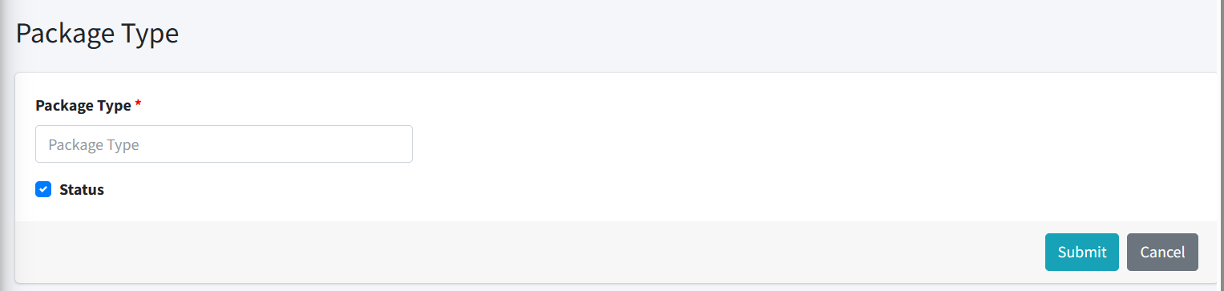

11 - Adventure: -

=> Here we have two options to **add adventure** and **view the adventure lists.**

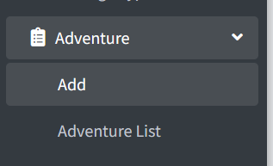

11.1 - Add: -

=> We can Add Adventure Type.

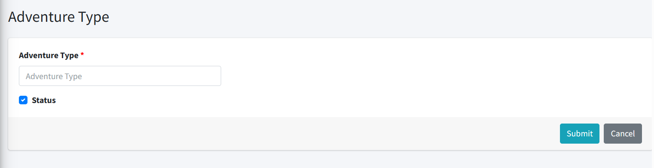

11.2 - Adventure list

=> We can see the adventure list.



12 - Destination: -

=> We have two options i.e., to **add a destination** and to **view the destination list.**

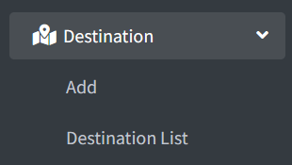

12.1 - Add: -

=> Here we can add a destination.

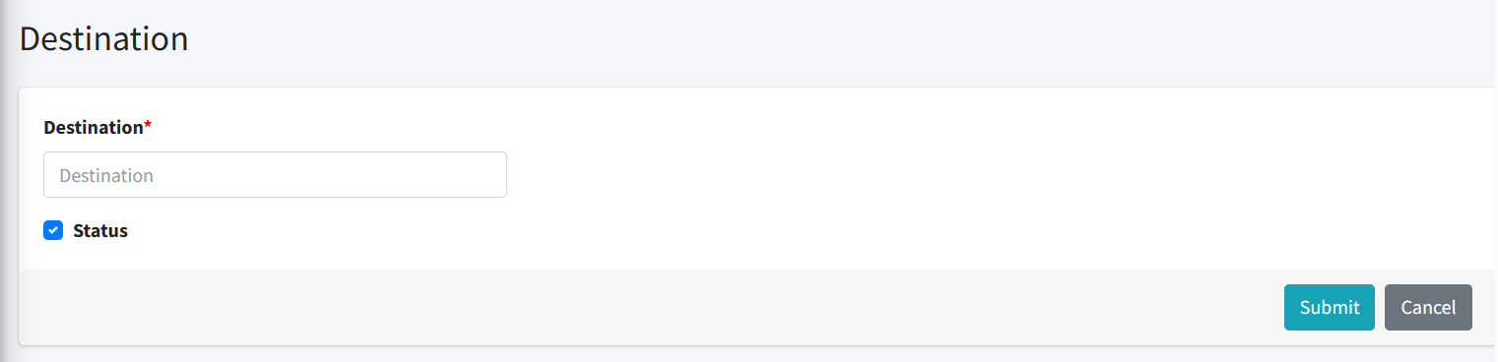

12.2 - Destination list: -

=> Here we see the destination list.

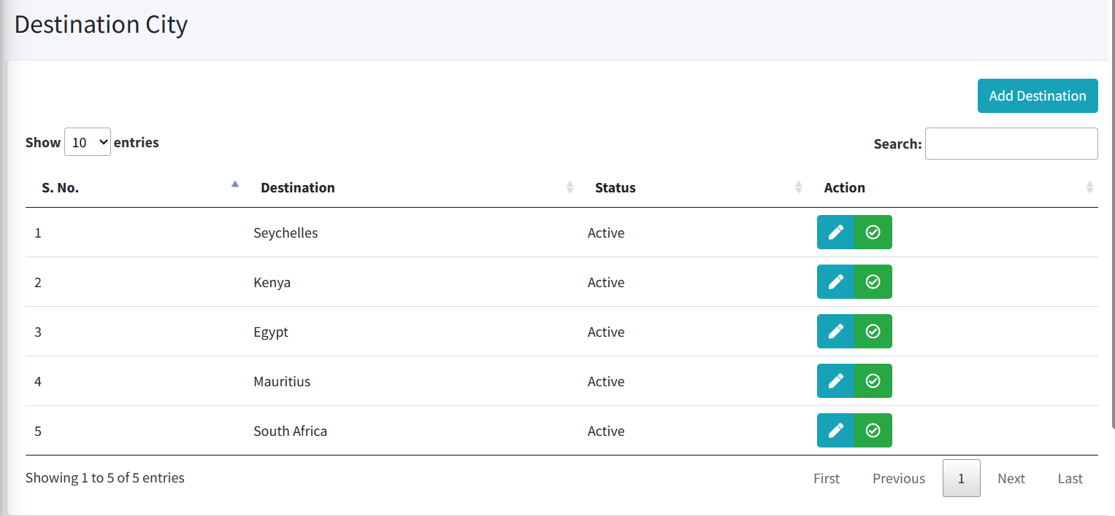

13 - Special Tour: -

=> We have two options i.e., to **add a special tour** and to **view the special tour list.**

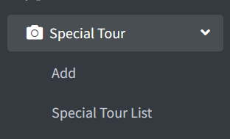

13.1 - ADD: -

Here we can Add a Special Tour.

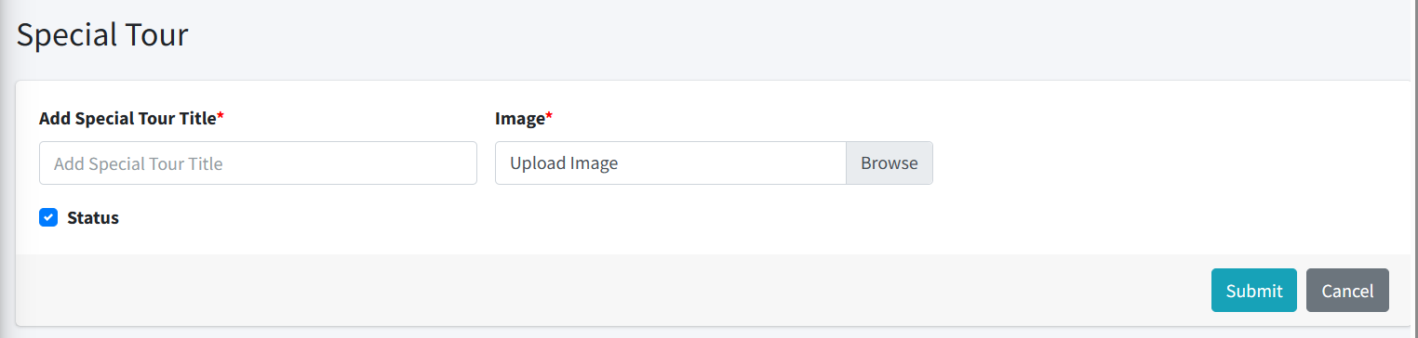

13.2 - Special Tour list: -

=> Here we can see the Tour list.

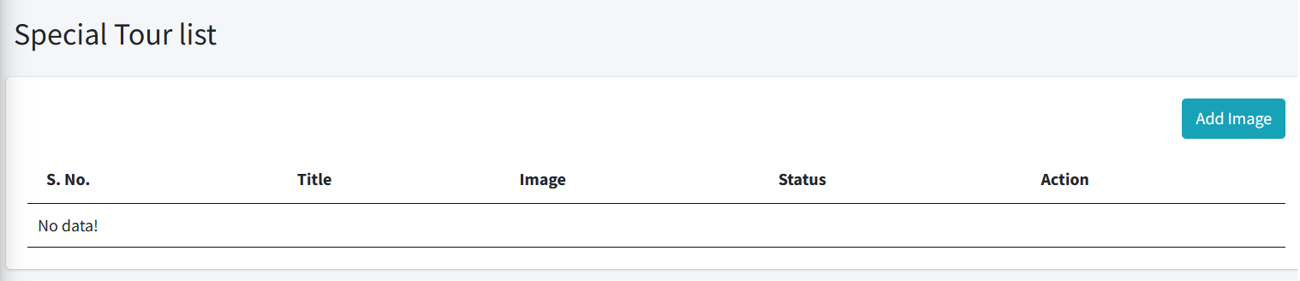

14 - Room Sharing: -

=> We have two options i.e., **Add a Room** and **View the Room Sharing List.**

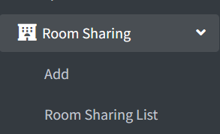

14.1 - Add: -

=> Here we can Add room Sharing.

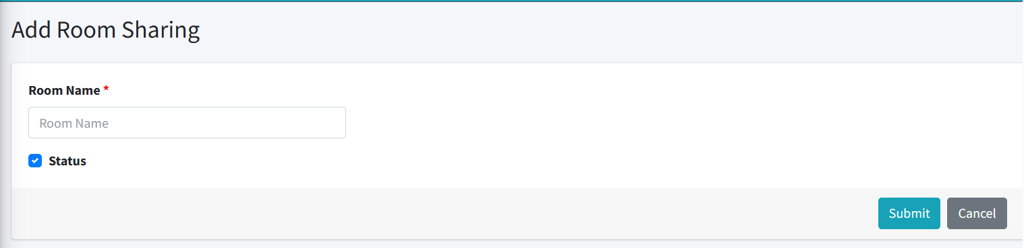

14.2 - Room Sharing List: -

=> Here we can see the room share list.

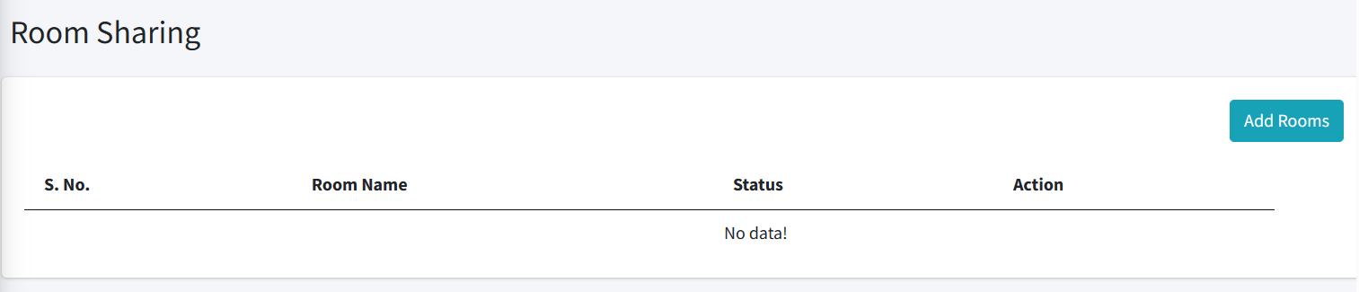

15 - Make a Tour: -

=> Here we have two options to **add a tour** and **view the tour list.**

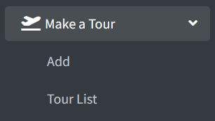

15.1 - Add: -

=> Here we can Add Make a Tour.

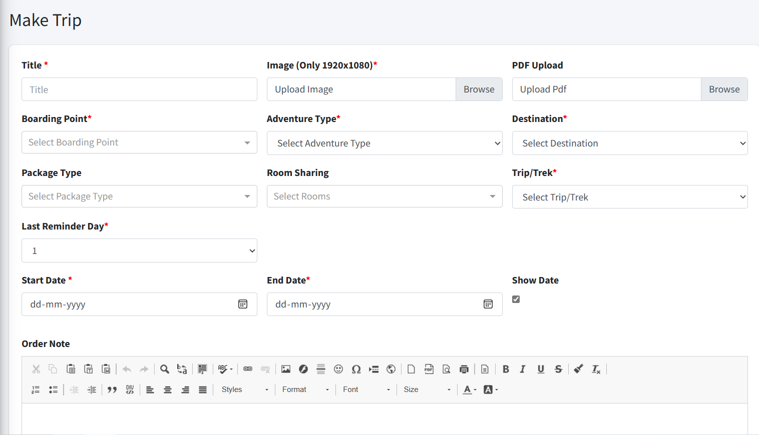

15.2 - Trip List: -

=> Here we can see the trip List.

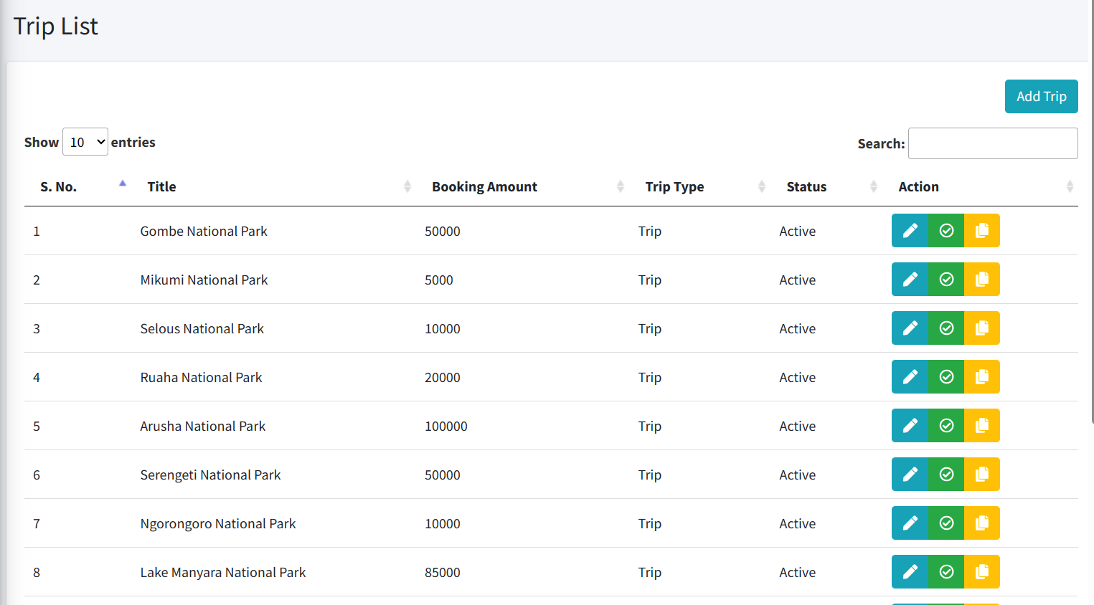

16 - Add Menu: -

=> Here we have the option **to add a menu.**

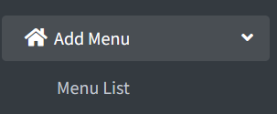

16.1 - Menu List: -

=> Here we can see the menu list.

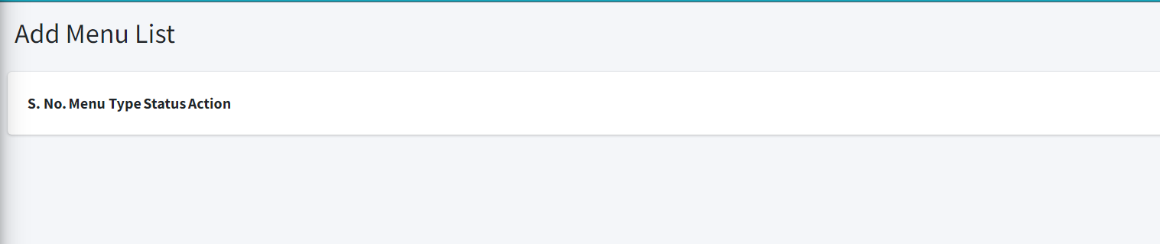

17 - Other Charge: -

=> Here we have Other Charge which means the add-ons charge and extra surge fees.

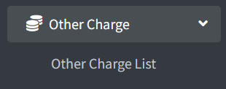

17.1 - Other Charge List: -

=> Here we can see the Other Charge list.

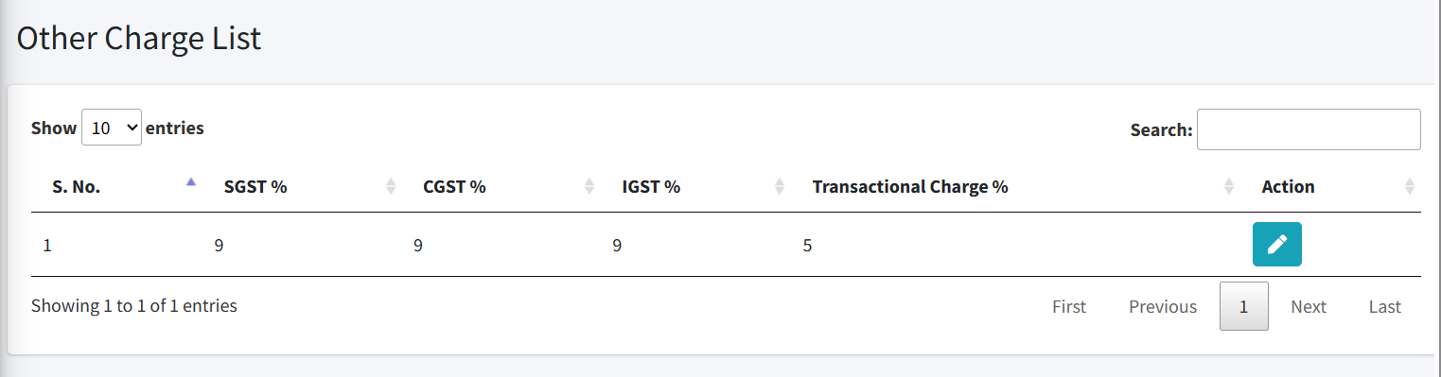

18 - Add Gallery: -

=> The admin has two options i.e., **to add the photos in gallery** and **to view the gallery list.**

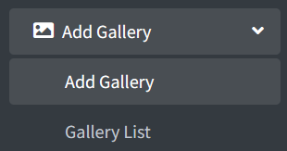

18.1 - Add Gallery: -

=> Here we can upload an Image.

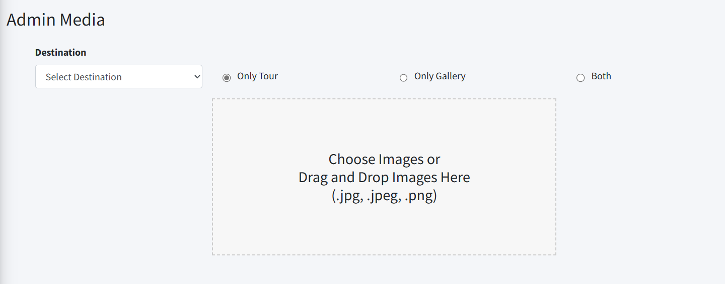

18.2 - Gallery List: -

=> Here you can see all uploaded photos.

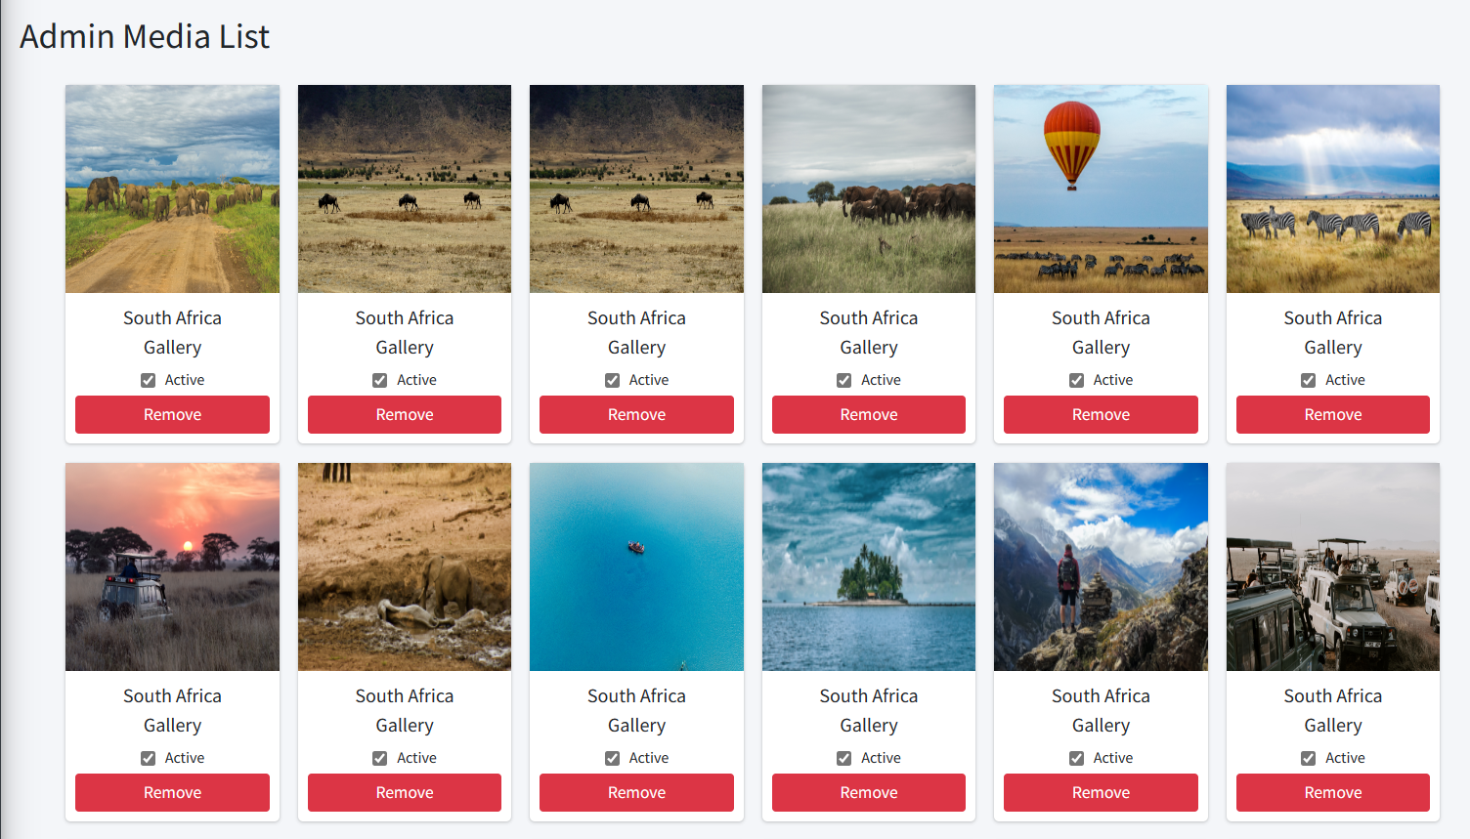

19 - Add Video: -

=> Here we have two options to **upload a video** and to **view the video list.**

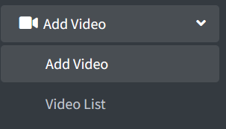

19.1 - Add Video: -

=> Here we can upload a video.

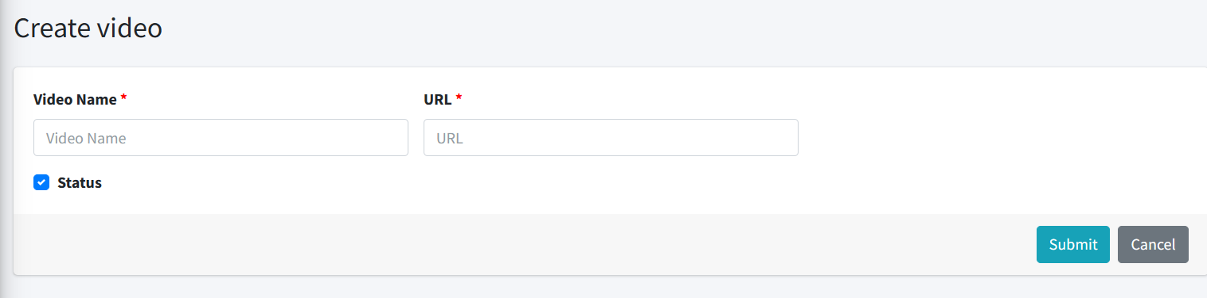

19.2 - Video list: -

=> Here we can see the video list.

